AP20110010611

O.RAJ KEERTHI

Report:

Symbol table is an important data structure created and maintained by compilers in order to store information.

Symbol table is used by both the analysis and the synthesis parts of a compiler.

Variable names, function names, objects, classes, interfaces are stored in the symbol table.

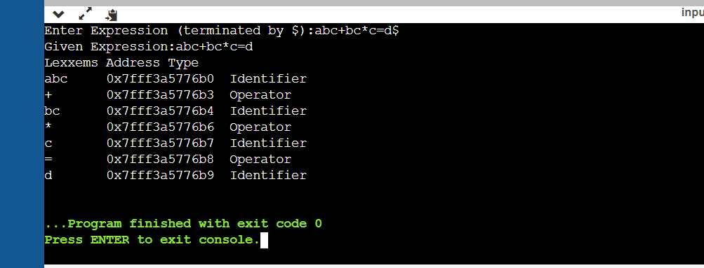

In Symbol Table we are taking expressions from user which contain some integers, characters and some operators. It will identify characters as identifiers, digits as constants. In the above output, abc, bc, c, d are identifiers and +, \*, = are operators.